C:\Users\Ashish Kumar Namdeo\Desktop\logo_small_word.tif

**STUDENTS’ GYMKHANA ELECTIONS**

**Year 2018-19**

Indian Institute of Technology, Guwahati

**Nomination Form**

File Ref: IITG/SAC/GYM18/Elections/Nominations/

Post contesting for: PG SENATORS

**Candidate details:**

|  |  |
| --- | --- |
| Name: PAPU KUMAR NAIK | |
| Roll No.: 146152006 | Dept. /Branch: CENTRE FOR THE  ENVIRONMENT |
| CPI: 8.15 (COURSE WORK)  Backlogs: NO | Semester: SEVENTH  Active Backlogs (if any): NO |
| Email Id: [papu.naik@iitg.ernet.in](mailto:papu.naik@iitg.ernet.in) | Contact No.: 8249314227 |
| Hostel: MSH | Room No.: Waitlisted |

Signature with date:

**Proposed by:**

|  |  |
| --- | --- |
| Name: SMRUTI RSNJAN DASH | |
| Roll No.: 146152008 | Dept. /Branch: CENTRE FOR THE  ENVIRONMENT |
| CPI: 7.3 (COURSE WORK) | Semester: SEVENTH |
| Email Id: [d.smruti@iitg.ernet.in](mailto:d.smruti@iitg.ernet.in) | Contact No.: 8812061986 |
| Hostel: LOHIT | Room No.: C-118 |

Signature with date:

**Seconded by:**

|  |  |
| --- | --- |
| Name: MANISH KUMAR DHIMAN | |
| Roll No.: 146107040 | Dept. /Branch: CHEMICAL ENGG. |
| CPI: 7.25(COURSE WORK) | Semester: SEVENTH |
| Email Id: [m.dhiman@iitg.ernet.in](mailto:m.dhiman@iitg.ernet.in) | Contact No.: 8473800290 |
| Hostel: MSH | Room No.: 216 |

Signature with date:

C:\Users\Ashish Kumar Namdeo\Desktop\logo_small_word.tif

**STUDENTS’ GYMKHANA ELECTIONS**

**Year 2018-19**

Indian Institute of Technology, Guwahati

File Ref: IITG/SAC/GYM18/Elections/Agenda/

Post contesting for: PG SENATORS

|  |
| --- |
| Name: PAPU KUMAR NAIK |
| Nick Name.: PAPU |
| Tagline (Punch line): Excellence in research and academics |

**Agendas:**

**Agenda 1: Women safety**

*Domain: Society and safety*

Proposal: In the past year, some incidents related to physical violence and misbehavior to women, have happened. These are not acceptable at any level. To counter these unfortunate incidents, I propose this for the safety of women.

Possible solution: Installation of CCTV camera in major places of campus. The CCTVs will be installed keeping in mind of the usual gathering points in campus and also shall not breach the privacy of residents. If the major areas are covered and monitored for 24x7 by security remotely, IITG can effectively put security guards for patrolling in unconventional area.

Plan of Action: If I am elected as senator, I will put this agenda into official senate meeting for discussion. After having a constructive debate, the action plan will be proposed considering the views of every member of Gymkhana council.

Extra sheets may be attached if needed.

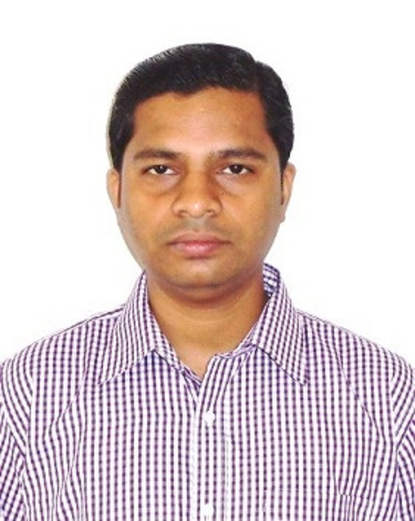

Photo graph

**Agendas and Declaration Form**

**Agenda 2: Proper maintenance of hostel kitchen drain**

*Domain: Cleanliness of Campus*

Proposal: Almost all drain which present in back side of the all hostels are kept open and not cleaned properly. Very pungent smell comes out from it. Mosquitos and flies are growing there, which is very unhygienic. That’s why sometimes the students are complaining for insects in food. This is severely effected to health of the student.

Possible solution: These drains will be cleaned regularly. Covering of the sewage line, sprinkling of disinfectant like bleaching power and phenyl.

Plan of Action: If I am elected as senator, I will put this agenda into official senate meeting for discussion. After having a constructive debate, the action plan will be proposed considering the views of every member of Gymkhana council.

**Agenda 3: Prize for publication**

*Domain: Incentives to students*

Proposal: I propose to IITG administration to give some kind of prize (money or certificate) for Ph.D. students for the best publication in their respective department or centre. This will encourage students to pay more concentration in research and ultimately lift the research excellence of IITG.

Possible solution: Small amount of fund should be allocated to all department and centre of the IITG for this purpose.

Plan of Action: If I am elected as senator, I will put this agenda into official senate meeting for discussion. After having a constructive debate, the action plan will be proposed considering the views of every member of Gymkhana council

**Agenda 4: printing for flex posters**

*Domain: Academic*

Proposal: There is no flex poster printing facility in campus. Thus, students are going city for the printing for the posters. Also, there are various technical and cultural events organized throughout the year in the campus, for this also posters and flexes are integral part for advertisements. Students have to go to city to print the posters and flexes. That absorbs an enormous time and energy.

Possible solution: To save time and money, the administration of IITG should purchase a printer for printing flex and poster. Students can print their posters at a discounted rate specified by IITG.

Plan of Action: If I am elected as senator, I will put this agenda into official senate meeting for discussion. After having a constructive debate, the action plan will be proposed considering the views of every member of Gymkhana council

Extra sheets may be attached if needed.

**Declaration by the candidate:**

I hereby declare that the above information is to the best of my knowledge. I do not have any disciplinary probation by the Institute and will abide by the rules and regulations laid for Gymkhana Election. I do not have any active backlogs to be cleared.

I know that any false information in this nomination form will lead to cancellation of my nomination and disciplinary action.

Signature of candidate with date: Signature of CEO

Former Senate member of my graduation university (Sambalpur University, Odisha, 2011-2012)

**Experiences (Credentials if any):**